User Guide

The program is a linear equation solver question bank. The program will provide two random linear equations and it will be the user’s job to find the point of interception between the two functions. Upon inputting the answers, the interface will tell you if the answer inputted is correct or incorrect and the correct answer will be provided if it is not correct. In order to use this program, an understanding of how to solve linear equations is necessary. It is recommended to be used by students in the 9th grade as that is when they are exposed to this concept.

This program can be run simply by importing the file into an java interpreter and the interface will be presented on the screen.

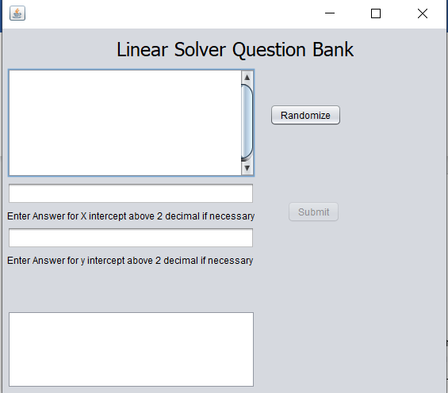Upon starting the program, you must press the “randomize” button for the program to submit. Before pressing the randomize button, the submit button will be disabled and no answers can be recorded.

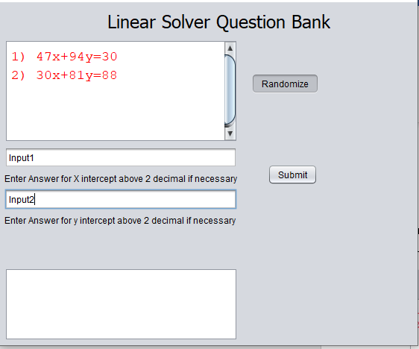Upon pressing the “randomize” button, two functions will be displayed on the upper left box. These two functions displayed will be the question generated by the program and what the user will have to solve for. The submit button will not be enabled to the user however no results will be shown unless both input fields have been edited. 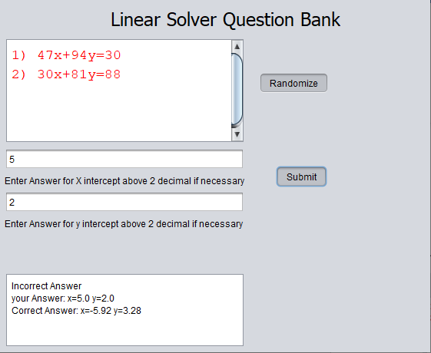Pressing the submit field with your answer inputted will return a statement stating whether the answer was correct. If the answer was incorrect, it will display the answer you have stated along with the correct answer.

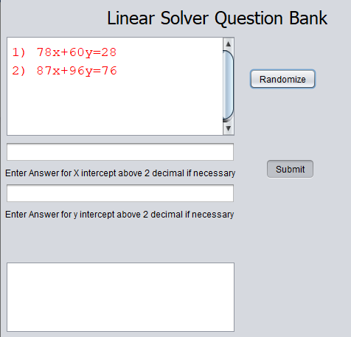If the “randomize” button is pressed once again, all text boxes except for the one displaying the question will be cleared. This reduces the need for the users to manually clear their input boxes, making the program easier to use.